Emily Wood  
SNHU CS 330  
Computational Graphics and Visualization  
June 18, 2023

**Reflection**

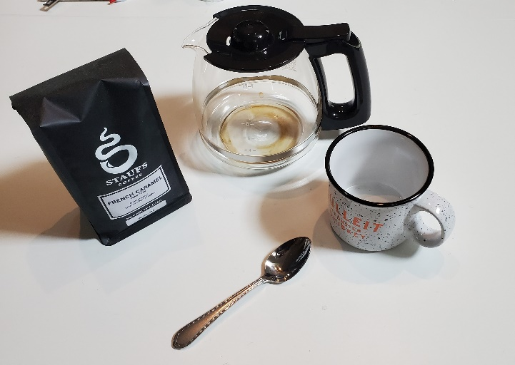

**Justify your development choices for your 3D scene.**  
When originally choosing objects for my scene, I tried to keep in mind the primitive objects that were available to us. I knew the coffee mug could use a cylinder and a torus. I knew the bag of coffee was a box. I knew I could use a cylinder and tapered cylinder for the spoon. I knew the coffee pot would take many primitive objects. The carafe would be a tapered cylinder, the handle would be a torus. The spout would be a 3-sided pyramid. The lid would be a cylinder. The ball on top of the lid would be a sphere. By ensuring all objects I selected included the available primitive shapes, I knew I could successfully create them within OpenGL. Although my table was originally white, I needed a contrasting color to highlight the objects, which is why I went with a grey plane. Originally the background of the entire scene was black and the coffee pot was getting lost, so I made that grey as well.

**Explain how the user can navigate your 3D scene.**

There are multiple ways to navigate the scene. First, the scene will move around with the position of the mouse. The mouse wheel will increase or decrease the speed of the movements. The W key will zoom in and the S key will zoom out. The Q key will move the camera up the scene and the E key will move the camera down. The A key will move the camera left and the D key will move the camera right. The O key will switch the view to Orthographic and the P key will switch it to perspective.

**Explain the custom functions in your program that you are using to make your code more modular and organized.**

I am using meshes provided by Brian Battersby within meshes.h and meshes.cpp. By using the function meshes.CreateMeses(), I am able to access the vertices within that class to avoid it all being in source.cpp. I am also utilizing the camera header for all of my navigation and viewing so that source.cpp is cleaner.